Agenda Item : 3 /01

= application site



Prince Edward Playing Fields Camrose Avenue | P/1564/20

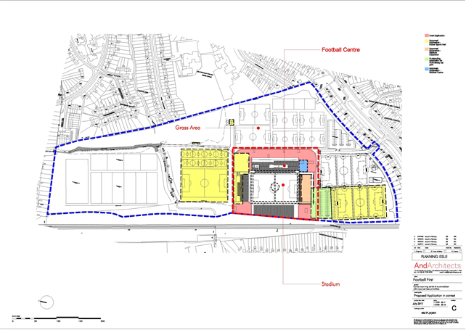
LONDON BOROUGH OF HARROW

PLANNING COMMITTEE

2nd September 2020

APPLICATION NUMBER: | P/1564/20
VALID DATE: | 8th JUNE 2020
LOCATION: | PRINCE EDWARD PLAYING FIELDS, CAMROSE AVENUE, EDGWARE (The HIVE FOOTBALL CENTRE)
WARD: | HARROW WEALD
POSTCODE: | HA8 6AG
APPLICANT: | FOOTBALL FIRST LTD
AGENT: | WSP INDIGO
CASE OFFICER: | NICOLA RANKIN
EXPIRY DATE: | 7th SEPTEMBER 2020

PROPOSAL

Outline application for Access Only: Redevelopment to provide four storey building with basement comprising of sporting higher education facility, student accommodation, hotel, medical diagnostic centre; plant and associated works

RECOMMENDATION A

The Planning Committee is asked to:

Refuse the application for the following reasons:

- The proposed uses comprising of a hotel, sporting higher education facility including student accommodation and medical diagnostics centre would give rise to inappropriate uses on the site which would be in direct conflict with the site’s allocation for community outdoor sport development and by reason of the site’s low accessibility, sitting outside of a town centre and insufficient evidence to demonstrate the need for the uses proposed, would give rise to an unsustainable development, contrary to the National Planning Policy Framework (2019), policies 3.16, 3.19 and 4.5 of The London Plan (2016), policies S5, E10G, SD7, S1 and S3B of The Draft London Plan - Intend to Publish (2019), core policies CS1 Z, F and L of the Harrow Core Strategy (2012), policies DM 34, DM 46 and DM 48B of the Harrow Development Management Policies Local Plan (2013) and Site MOS5 of the Harrow Site Allocations (2013).

- The proposed development would result in a direct loss of protected designated open space and would not provide a use which is ancillary or appropriate to the existing open space, contrary to the National Planning Policy Framework (2019), policy 7.18 of The London Plan (2016), policy G4 of The Draft London Plan - Intend to Publish (2019), core policy CS1 F of the Harrow Core Strategy (2012) and Policy DM18 of the Harrow Development Management Policies Local Plan (2013).

- The proposed development, in the absence of a Transport Assessment and Travel Plan, fails to demonstrate the impacts of the development on the surrounding highway network, and to propose measures to promote sustainable travel modes and to reduce the effects of travel by car. Insufficient information has therefore been provided to demonstrate that the proposals would not result in unacceptable harm to the surrounding highway network through increased pressure on local parking amenity and on local transport infrastructure from excessive vehicle trips, contrary to the National Planning Policy Framework (2019), policies 6.3, 6.10 and 6.13 of The London Plan (2016), policies T1, T2, T4, and T6 of the Draft London Plan – Intend to Publish (2019), policy 1 of the Mayor’s Transport Strategy, policy CS1 R of the Harrow Core Strategy (2012) and policies DM 42 and DM 43 of the Harrow Development Management Policies Local Plan (2013).

- The proposed development, in the absence of a Preliminary Ecological Assessment and the site’s close proximity to the adjoining Borough Grade I Site of Importance for Nature Conservation and the River Brent, fails to demonstrate that biodiversity value of the surrounding area would not be harmed, protected or enhanced, contrary to the National Planning Policy Framework (2019), policy 7.19 of The London Plan (2019), policy G6 of the Draft London Plan - Intend to Publish (2019), and policies DM 48 A b, DM 20 and DM 21 of the Harrow Development Management Polices Local Plan (2013).

- The proposal, by reason of an unsatisfactory Flood Risk Assessment, fails to demonstrate that the proposed development would result in a net reduction in flood risk, be resistant and resilient to flooding, would not exacerbate the risk of flooding within the site or increase the risk and consequences of flooding elsewhere or provide a dry means of escape for the future users, to the detriment of the safety of the adjoining occupiers and the future users of the development, contrary to the National Planning Policy Framework (2019), policies 5.12 and 5.13 of The London Plan (2016), policies SI12 and SI 13 of the Draft London Plan (2019), Core Policy CS1 U of Harrow Core Strategy (2012) and policies DM 9 and DM 10 of the Harrow Development Management Polices Local Plan (2013).

- The proposed development, by reason of the indicated heights and conflicting floorspace figures proposed, would be likely to result in a harmful, bulky and unduly dominant addition to the site which would significantly detract from the open character of the site and the surroundings, and would fail to respect the existing development on the site or contribute positively to the site’s setting and the quality of the open space, contrary to the National Planning Policy Framework (2019), policies 7.4 B and 7.6 B of The London Plan (2017), policies D1 and D3 of the Draft London Plan (2019), core policy CS 1 B and F of the Harrow Core Strategy (2012) and policy DM 18 C/D of the Harrow Development Management Policies Local Plan (2013).

- The proposed development, by reason of the excessive amount of development proposed, the proposed uses and the absence of a Noise Assessment or Lighting Impact Assessment, would give rise to unacceptable harmful outlook and visual impacts, as well as potential unreasonable noise and disturbance impacts from the increased intensity of use of the site, to the detriment of the residential and visual amenities of the adjacent neighbouring occupiers, contrary to the National Planning Policy Framework (2019), policies 7.4 B, 7.6B and 7.15 of The London Plan (2016), policies D3, D13 and D14 of the Draft London Plan - Intend to Publish (2019) and policy DM 1 of the Harrow Development Management Policies Local Plan (2013).

- The proposed development, in the absence of an Air Quality Assessment, fails to demonstrate that the proposed development would be Air Quality Neutral and would not have the potential to contribute to a deterioration in air quality in the locality, to the detriment of the future users of the site and wider area and the overall environmental quality of the London Borough of Harrow, contrary to the National Planning Policy Framework (2019), policy 7.14 of The London Plan (2016), policy of the SI 1 of the Draft London Plan – Intend to Publish (2019) and polices DM 1 and DM 12 of the Harrow Development Management Policies Local Plan (2013).

REASON FOR THE RECOMMENDATION

The proposed development is considered to be unacceptable in principle and is contrary to all the national, regional and local plan policies stated above.

INFORMATION

This application is reported to Planning Committee as it has been called in by a Nominated Member in the public interest. The application is therefore referred to the Planning Committee as it does not fall within any of the provisions set out at paragraphs 1(a) – 1(h) of the Scheme of Delegation dated 12th December 2018.

Statutory Return Type: | Major Development
Council Interest:  Net additional Floorspace: | N/A  52, 788 sqm
GLA Community Infrastructure Levy (CIL): Contribution (provisional): | £3,347,280 (excluding indexation)
Local CIL requirement: | £3,068,340 (excluding indexation)

HUMAN RIGHTS ACT

The provisions of the Human Rights Act 1998 have been taken into account in the processing of the application and the preparation of this report.

EQUALITIES

In determining this planning application, the Council has regard to its equalities obligations including its obligations under section 149 of the Equality Act 2010.

For the purposes of this application there are no adverse equalities issues.

S17 CRIME & DISORDER ACT

Policies 7.3.B and 7.13.B of The London Plan and Policy DM1 of the Development Management Policies Local Plan require all new developments to have regard to safety and the measures to reduce crime in the design of development proposal. It is considered that the development does not adversely affect crime risk. However, a condition could be added at the Reserved Matter Stage for evidence of certification of Secure by Design Accreditation for the development, had the proposal been otherwise considered acceptable.

- SITE DESCRIPTION

  - The Hive Football Centre (formerly Prince Edward Playing Fields) comprises former educational sports grounds, designated as Open Space and allocated for Community Outdoor Sports Use. It is now occupied by a football stadium with ancillary facilities and open-air grass and synthetic football pitches.

  - The wider stadium site (approx 17ha) is bound by the Jubilee Line railway to the west, with residential properties fronting Aldridge Avenue on the other side of the embankment, residential properties fronting Whitchurch Lane to the north and those on Camrose Avenue to the south. Those properties on Camrose Avenue have gardens that adjoin the site, the majority of which have chain mesh means of enclosure. To the south of those gardens, on the other side of a road is a large bund, which limits views into the site and the existing artificial floodlit pitches beyond it. To the east, the site adjoins residential properties along Buckingham Gardens and St David’s Drive and Little Stanmore Nursery, First and Middle Schools.

  - The subject site relates to the area surrounding the main stadium stands. The proposed area to be infilled currently contains predominantly hard surface circulation space with some small areas of green landscape. The hard surface areas provide car parking and coach parking spaces, general access and circulation space and some single storey ancillary structures

  - The section of railway embankment that adjoins the western site boundary is identified as a Site of Nature Conservation Importance.

  - Levels at the site fall from the north to the Edgware Brook, which crosses the site, and then rises again to Camrose Avenue.

  - The part of the site adjacent to the Brook is in Flood Zone 3a/3b (including an Environment Agency flood defence bund), with other parts of the site within Flood Zone 2.

  - The main vehicular access to the site is from Camrose Avenue, with secondary access (pedestrian only) from Whitchurch Lane.

  - The football stadium at the site is used by Barnet Football Club, a Football League side. The stadium has a maximum permitted attendance of 8500 which was granted under planning application P/2764/17.

  - There are 413 parking spaces on the site currently which is comprised of parking in the following areas:
- 234 parking spaces in the main surface car park
- 86 spaces in the triangular car park to the south of the site
- 44 matchday/VIP spaces to the front of the East Stand and
- 49 spaces on the two service road at the south of the site

  - The site is located adjacent to Canon’s Park Underground Station which is served by the Jubilee Line. The PTAL rating for the site ranges from 0 (poor) to 3 (average), thought the majority of the site is covered by a rating of 1a/1b.

- PROPOSAL

  - The proposal seeks outline application for Access Only for redevelopment to provide a four-storey building with basement, comprising of sporting higher education plant facility, student accommodation, hotel, medical diagnostic centre together with associated works

  - Indicative site plans, floorplans and elevations have been provided. The amount of floorspace proposed in the development is unclear as the Design and Access Statement outlines a figure of 45, 990sqm whereas the application form provides a figure of 52,788sqm. The development is indicated to be four storeys in height with basement. However, not all of the development parameters have been specified, including maximum and minimum footprint or building height.

  - The proposed hotel would wrap around and infill the existing stadium stands. It is indicated that there would be circa 150 bedrooms of which 106 would be for conventional hotel use.

  - It is proposed that other rooms within the hotel would be dedicated for patients visiting the TIC Health and Imaging Centre (the applicant’s health facility), which already exists on site. A new TIC cancer screening centre is also proposed as part of this application. It is outlined that the proposed rooms associated with the imaging centre would be larger, in order to accommodate families and in-room visits from medical practitioners if required. The Planning Statement notes that 96 medical bed spaces within the hotel would be provided for the screening centres which conflicts with the numbers of conventional hotel rooms outlined above.

  - In addition to the above, it is also proposed to provide student accommodation and teaching facilities for the University College of Football (UCFB). It is proposed that UCFB facilities would be provided as an extension to the west stand. The proposed facilities include the provision of 19 lecture rooms/auditoria for teaching students and 44 dormitories as onsite accommodation.

  - The proposal would include other ancillary facilities including a fitness suite, 25m swimming pool, and restaurant, bar area and enhanced conferencing facilities.

- RELEVANT PLANNING HISTORY

  - A summary of the relevant planning application history is set out in the table below:

Reference | Description | Decision
EAST/148/01/OUT | Outline: football stadium, terraces, stand & clubhouse, floodlights to ground, artificial pitch & tennis courts, health & fitness facilities, parking, vehicular access from Camrose Avenue | Approved: 11th April 2003
P/1087/03/DVA | Variation of condition 13 of planning permission East/148/01/OUT to provide revised parking layout | Approved: 29th July 2003
P/898/03/CDP | Details of design and appearance of building and landscaping pursuant to condition 2 of outline planning perm. East/148/01/OUT for football stadium  associated works | Approved: 04th August 2003
P/0002/07 | Redevelopment for enlarged football stadium and clubhouse, floodlights, games pitches, banqueting facilities, health and fitness facility, internal roads and parking | Approved: 08th April 2008
P/1321/08 | Alterations and internal changes to east stand and change of use of part of first floor of east stand from D2 (assembly and leisure) to primary care trust premises | Approved: 06th October 2008
P/1226/09 | S.73 application to vary condition 27 (development within the area liable to flood) attached to planning permission P/0002/07 | Approved: 25th August 2009
P/2022/09 | Variation of condition 18 (external lighting) pursuant to planning permission ref: P/0002/07/CFU dated 8 April 2008 from 'All exterior lighting other than floodlighting shall be extinguished on any day not later than 22:30 hours, except lighting not more than 1m above the finished road or car park level that shall be extinguished not more than 60 minutes after the end of any match or event' to 'All exterior lighting other than floodlighting shall be extinguished on any day not later than 22:30 hours, except lighting not more than 1m above the finished road and car park level that shall be extinguished not more than 60 minutes after the end of any match or event.' | Approved: 06th November 2009
P/2257/09 | Variation of condition 17 (floodlighting) pursuant to planning permission ref: P/0002/07/CFU dated 8 April 2008 from 'The floodlighting hereby permitted for playing surfaces shall only be used on any day up to 2200 hours except when evening matches are being played at the main stadium when floodlighting shall only be used up to 2300 hours' to 'The floodlighting hereby permitted for playing surfaces shall only be used on any day up to 2300 hours, until commencement of use of the playing surface of the main stadium, at which time floodlighting for the main stadium shall only be used on any day up to 2300 hours, and any other floodlighting within the site hereby permitted for playing surfaces shall only be used on any day up to 2230 hours'. | Refused: 29th December 2009
P/2912/09 | Variation of condition 17 (floodlighting) of planning permission ref: P/0002/07 dated 8 April 2008 from `the floodlighting hereby permitted for playing surfaces shall only be used on any day up to 22.00 hours except when evening matches are being played at the main stadium when floodlighting shall only be used up to 23.00 hours' to `the floodlighting hereby permitted for playing surfaces shall only be used on any day up to 22.30 hours except when evening matches are being played at the main stadium when floodlighting shall only be used up to 23.00 hours'; variation of condition 18 (external lighting) from `all exterior lighting other than floodlighting shall be extinguished on any day not later than 22:30 hours, except lighting not more than 1m above the finished road or car park level that shall be extinguished not more than 60 minutes after the end of any match or event' to `exterior lighting other than floodlighting shall be extinguished on any day not later than 23.00 hours except lighting in the main car park which shall be extinguished not later than 23.30 hours. when holding a match or event, lighting not more than 1m above the finished road and car park lighting shall be extinguished not more than 60 minutes after the end of such match or event' | Approved: 15th June 2010
P/1693/12 | Variation of condition 17 (floodlighting) of planning permission ref: P/0002/07 dated 8 April 2008 from `the floodlighting hereby permitted for playing surfaces shall only be used on any day up to 22.00 hours except when evening matches are being played at the main stadium when floodlighting shall only be used up to 23.00 hours' to `the floodlighting hereby permitted for playing surfaces shall only be used on any day up to 22.30 hours except when evening matches are being played at the main stadium when floodlighting shall only be used up to 23.00 hours'  Variation of condition 18 (external lighting) from `all exterior lighting other than floodlighting shall be extinguished on any day not later than 2230 hours, except lighting not more than 1m above the finished road or car park level that shall be extinguished not more than 60 minutes after the end of any match or event' to `exterior lighting other than floodlighting shall be extinguished on any day not later than 23.00 hours except lighting in the main car park which shall be extinguished not later than 23.30 hours. when holding a match or event, lighting not more than 1m above the finished road and car park lighting shall be extinguished not more than 60 minutes after the end of such match or event' | Approved: 10th September 2012
P/2807/12 | Non-material amendment to add a condition detailing approved plans to planning permission P/0002/07 dated 08/04/2008 for redevelopment for enlarged football stadium and clubhouse, floodlights, games pitches , banqueting facilities, health and fitness facility, internal roads and parking | Approved: 27th November 2012
P/0665/13 | Variation of condition 29 (approved plans - added through application P/2807/12) attached to P/0002/07 dated 08/04/2008 for 'Redevelopment for enlarged football stadium and clubhouse, floodlights, games pitches , banqueting facilities, health and fitness facility, internal roads and parking' to allow minor amendments to the stadium comprising: Phase 1: internal and external alterations to east stand including additional row of seats; increase in height, depth and capacity of west stand including camera position; reduction in capacity of standing areas; increase in height of floodlights and re-siting of southern floodlights; additional turnstiles, spectator circulation, fencing, food kiosks and toilets; alterations to parking areas. Phase 2: replace north stand with seated stand; reduction in capacity of standing area in southern stand; extension to rear of west stand to provide indoor spectator space (total stadium capacity not to exceed 5176 as previously approved) | Refused: 11th September 2013  Appeal allowed: 19th December 2014
P/4092/14 | Single storey side to rear extension to the east stand to create an enlarged medical centre and box office security; provision of two internal chiller units and three internal air conditioning units | Approved: 23rd March 2015
P/4096/14 | First floor side extension to the east stand to create an enlarged banqueting suite and provision of a new entrance | Approved: 13th April 2015
P/2004/15 | Display one internally illuminated free standing sign | Approved: 02nd July 2015
P/2191/15 | Variation of condition 1 (drawing numbers) attached to planning permission P/0665/13 allowed on appeal reference  APP/M5450/A/14/2215248 dated 19/12/2014 to allow for a larger North Stand and associated facilities than that approved by the original consent for an enlarged football stadium and clubhouse, floodlights, games pitches,  banqueting facilities, health and fitness facility, internal roads and parking. Phase 1 involves internal and external  alterations to the East Stand including an additional row of seats, an increase in the height, depth and capacity of the  West Stand, including camera position, reduction in capacity of standing areas, increase in the height of floodlights,  additional turnstiles, spectator circulation, fencing, food kiosks and toilets and alterations to the parking areas. Phase 2 involves the replacement of the North Stand with a seated stand, reduction in the capacity of the standing area in  the South Stand and an extension to the rear of the West Stand to provide indoor spectator space | Approved: 20th July 2015
P/3255/16 | Erection of temporary spectator stand adjacent to the academy pitch (training area a); footpath to provide pedestrian access to the temporary stand | Appeal allowed: 23rd December 2016
P/5204/16 | Variation of condition 1 (drawing numbers) attached to planning  application P/0665/13 allowed on appeal under reference  APP/M5450/A/14/2215248 dated 19/12/2014 to allow for a larger North Stand (increased height and depth, and larger bar area) and the provision of a building to facilitate a ticket office and turnstiles. The scheme allowed on appeal was for an enlarged football stadium and clubhouse, floodlights, games pitches, banqueting facilities, health and fitness facility, internal roads and parking. Phase 1 involved internal and external alterations to the East Stand including an additional row of seats, an increase in the height, depth and capacity of the West Stand, including camera position, reduction in capacity of standing areas, increase in the height of floodlights, additional turnstiles, spectator circulation, fencing, food kiosks and toilets and alterations to the parking areas. Phase 2 involved the replacement of the North Stand with a seated stand, reduction in the capacity of the standing area in the South Stand and an extension to the rear of the West  Stand to provide indoor spectator space extension | Refused: 23rd June 2017  Appeal allowed Ref: app/m5450/W/ 17/ 3188361
P/3352/16 | Non-material amendment to planning permission reference P/2191/15 dated 17/07/15 to increase the depth of the north stand at ground floor level, increase the height of the north stand and increase the width of the north stand | Refused: 25th August 2016
P/2764/17 | Erection of a new South stand; new medical facilities, community facilities and commercial floorspace to the rear of the south stand; replacement of East stand seating with terraces; single deck above existing car park and increase in the total capacity of the stadium from 5,176 to 8,500 | Granted 28th February 2018
P/4485/17 | Variation of Condition 1 (Approved plans) attached to planning permission P/0665/13 allowed on appeal reference APP/M5450/A/14/2215248 dated 19/12/14 to allow for a larger north stand and associated facilities than approved by the original consent | Granted 2nd November 2018
P/2763/17 | Erection of an indoor academy building with an indoor 3G pitch, a new 11-a-side 3G pitch, eight 5-a-side pitches, a new indoor sports hall, a permanent ticket-office and club-shop, a permanent academy spectator stand and WC and snack shop porta cabins. | Granted 18th July 2019
P/4134/19 | Outline Application for all matters reserved: Construction of a five storey car park | Refused 30th July 2020

- CONSULTATION

  - A total of 2538 consultation letters were sent to neighbouring properties regarding this application.

  - The public consultation period expired on 13 August 2020. Total of 3 objections were received.

  - The proposal was advertised for the following reasons:

- Press Advert: Major Development /Departure from Development Plan Expiry: 06/008/2020
- Site Notice: Major Development /Departure from Development Plan Expiry: 20/08/2020

  - A summary of the neighbour consultation responses are set out below:

- The addition of a hotel would add to more traffic and parking issues
- There would be potential for additional noise from the hotel from functions and also of fire alarms and bugler alarms going off at night like it did in July.
- There will be more unnecessary people hanging around the area on match days with the hotel facilities – already there is drug taking and anti-social behaviour on match days.
- They already have a diagnostic facility and creating a bigger one will result in more parking issues.
- The owners of this site over the years have continued to add additional facilities and structures which have severely impacted upon residents living around the Hive.
- The Hive has enough facilities already and there is no justification to have these additional facilities when the surrounding infrastructure is already overused and inadequate.
- The application is an overdevelopment, a 200 room hotel is not necessary and would involve night time early hours noise and disturbance for nearby residents who already suffer evening noise and light pollution when matches are played.
- Where are 200 cars going to be parked? How much more traffic will be involved?
- More building on a flood plain will lead to more chance of the nearby houses being flooded.

Statutory and Non Statutory Consultation

  - A summary of the consultation responses received along with the Officer comments are set out in the Table below.

Consultee and Summary of Comments

Sport England:
It is understood that the proposal prejudices the use, or leads to the loss of use, of land being used as a playing field or has been used as a playing field in the last five years, as defined in The Town and Country Planning (Development Management Procedure) (England) Order 2015 (Statutory Instrument 2015 No. 595). The consultation with Sport England is therefore a statutory requirement.
Sport England has considered the application in light of the National Planning Policy Framework (particularly Para 97) and against its own playing fields policy, which states:
'Sport England will oppose the granting of planning permission for any development which would lead to the loss of, or would prejudice the use of:
- all or any part of a playing field, or
- land which has been used as a playing field and remains undeveloped, or
- land allocated for use as a playing field
unless, in the judgement of Sport England, the development as a whole meets with one or more of five specific exceptions.'
Sport England's Playing Fields Policy and Guidance document can be viewed via the below link:
https://www.sportengland.org/how-we-can-help/facilities-and-planning/planning-for-sport#playing_fields_policy
Having assessed the application, Sport England is satisfied that the proposed development meets exception 3 of our playing fields policy, in that:
'The proposed development affects only land incapable of forming part of a playing pitch and does not:
- reduce the size of any playing pitch
- result in the inability to use any playing pitch (including the maintenance of adequate safety margins and run-off areas);
- reduce the sporting capacity of the playing field to accommodate playing pitches or the capability to rotate or reposition playing pitches to maintain their quality;
- result in the loss of other sporting provision or ancillary facilities on the site; or
- prejudice the use of any remaining areas of playing field on the site.'
In assessing this application, I also consulted the Football Foundation on behalf of the FA. They confirmed that there does not appear to be any impact on football or existing funded facilities. The design is a wraparound construction with the building going around the stadium. This is being built on existing car parks / spare areas. It appears that they plan to construct a multi-storey car park to mitigate this loss. The FF on behalf of the FA do not object to the proposal.
This being the case, Sport England does not wish to raise an objection to this application.

Infrastructure Protection – TFL Engineering:

Though we have no objection in principle to the above planning application, there are a number of potential constraints on the redevelopment of a site situated close to railway infrastructure. Therefore, it will need to be demonstrated to the satisfaction of LUL engineers that:

- our right of support is not compromised
- the development will not have any detrimental effect on our structures either in the short or the long term
- the design must be such that the loading imposed on our structures is not increased or removed
- We offer no right of support to the development of the land.
Therefore we request that the grant of planning permission be subject to conditions.

Thames Water:

Waste Comments
With the information provided, Thames Water has been unable to determine the waste water infrastructure needs of this application. Thames Water has contacted the developer in an attempt to obtain this information and agree a position for FOUL WATER drainage, but have been unable to do so in the time available and as such, Thames Water request that the following condition be added to any planning permission. “No properties shall be occupied until confirmation has been provided that either:- 1. Capacity exists off site to serve the development, or 2. A housing and infrastructure phasing plan has been agreed with Thames Water. Where a housing and infrastructure phasing plan is agreed, no occupation shall take place other than in accordance with the agreed housing and infrastructure phasing plan, or 3. All wastewater network upgrades required to accommodate the additional flows from the development have been completed. Reason - Network reinforcement works may be required to accommodate the proposed development. Any reinforcement works identified will be necessary in order to avoid sewage flooding and/or potential pollution incidents. The developer can request information to support the discharge of this condition by visiting the Thames Water website at thameswater.co.uk/preplanning. Should the Local Planning Authority consider the above recommendation inappropriate or are unable to include it in the decision notice, it is important that the Local Planning Authority liaises with Thames Water Development Planning Department (telephone 0203 577 9998) prior to the planning application approval.

With the information provided Thames Water has been unable to determine the waste water infrastructure needs of this application. Thames Water has contacted the developer in an attempt to obtain this information and agree a position for SURFACE WATER drainage, but have been unable to do so in the time available and as such Thames Water request that the following condition be added to any planning permission. “No properties shall be occupied until confirmation has been provided that either:- 1. Capacity exists off site to serve the development or 2. A housing and infrastructure phasing plan has been agreed with Thames Water. Where a housing and infrastructure phasing plan is agreed, no occupation shall take place other than in accordance with the agreed housing and infrastructure phasing plan. Or 3. All wastewater network upgrades required to accommodate the additional flows from the development have been completed. Reason - Network reinforcement works may be required to accommodate the proposed development. Any reinforcement works identified will be necessary in order to avoid flooding and/or potential pollution incidents. The developer can request information to support the discharge of this condition by visiting the Thames Water website at thameswater.co.uk/preplanning. Should the Local Planning Authority consider the above recommendation inappropriate or are unable to include it in the decision notice, it is important that the Local Planning Authority liaises with Thames Water Development Planning Department (telephone 0203 577 9998) prior to the planning application approval.

Water Comments
With regard to water supply, this comes within the area covered by the Affinity Water Company. For your information the address to write to is - Affinity Water Company The Hub, Tamblin Way, Hatfield, Herts, AL10 9EZ - Tel - 0845 782 3333.

Supplementary Comments

There is no drainage details provided as part of this application and we would seek to understand the proposed points of connection to the public network and the proposed flow rates discharged into each. We would like to better understand how that compares to the existing site.

Environment Agency: The proposed development falls within flood zone 2, which is land being defined in the planning practice guidance as being at risk of flooding. We have produced a series of standard comments for local planning authorities and planning applicants to refer to on lower risk development proposals. These comments replace direct case by case consultation with us. The proposal falls within this category. These standard comments are know as Flood Risk Standing Advice (FRSA).
Note to LPA:
As identified in your Strategic Flood Risk Assessment, part of the wider site is located within Flood zone 3b (functional floodplain). The development would not be appropriate in areas defined in Flood Zone 3b and we suggest this is recognised in the decision notice of any outline planning permission.

Greater London Archaeological Advisory Service: No objection, I conclude that the proposal is unlikely to have a significant effect on the heritage assets of archaeological interest.

Greater London Authority: Comments awaited.

LBH Road Network Management: This application at present does not really affect highways as access already exists and wide enough so no concerns from my end. Only thing they may need to do is speak to me about their travel plan.

LBH Highways Authority: Objection, I cannot properly assess this proposal due to insufficient information.
Individually, each of these uses have a significant impact potential therefore, it is essential that a full, Healthy Streets Transport Assessment and associated documents (eg travel plan, CLP etc) are submitted for consideration. I don’t see how we can consider access on its own really because the arrangements might be acceptable subject to mitigation but details are needed in order to determine what mitigation would be required.
LBH Drainage Authority: We do object to the proposed development due to flood risk and an FRA is required to satisfy us that it can be safe with no increased risk to the neighbouring properties.
LBH Biodiversity: It is apparent that there has been no consideration of the mitigation hierarchy nor other biodiversity matters in connection with the scheme’s design and - despite the previous applications for this site - the application form incorrectly claims that there are no features of biodiversity interest that might be affected within its vicinity.
No information has been presented in relation to
- the potential impacts of the scheme for which outline permission and approval of access arrangements are sought on the (1) adjoining section of the Canon’s Park and Stanmore Railway Embankments SINC, which is of Borough Grade 1 importance or (2) the River Brent which in addition to being an important blue-green corridor itself, connects with a number of wildlife sites downstream, including the Welsh Harp SSSI;
- the cumulative impacts of this scheme and other previously permitted development;
- the biodiversity gain that the scheme will need to deliver to address the policy requirements of the NPPF, London Plan and Harrow Core Strategy.
There is insufficient information to determine whether the proposal would be in conflict with local plan policy DM20 with regard to potential impacts on biodiversity conservation. Moreover, the applicant has neglected to address the requirements of local plan policy DM21 within their scheme.
Given the nature and scale of the proposal, it is suggested that the best course would be to advise withdrawal and resubmission once the above points have been addressed and that formal pre-application advice would be beneficial. As the application stands the only other option is refusal.
LBH Policy: The proposed developments, by reason of the range of uses, fail to demonstrate that they are ancillary to the existing outdoor sports use on the site. By reason of not being ancillary to the primary use of the site, it is considered that the applicant has failed to demonstrate that the uses would be within the community they intend to serve. By reason of this, the proposed medical facility and UCFB would fail to accord with policy DM46B of the HDMP (2013).

It is considered that in this instance, the principle of development on designated open space that is not ancillary and necessary to the functioning of the open space, resulting in a loss, in an area which there is an evidenced deficiency, is unable to be supported.

5.0 POLICIES

5.1 Section 38(6) of the Planning and Compulsory Purchase Act 2004 requires that:

‘If regard is to be had to the Development Plan for the purpose of any determination to be made under the Planning Acts, the determination must be made in accordance with the Plan unless material considerations indicate otherwise.’

5.2 The Government has issued the National Planning Policy Framework [NPPF 2019] sets out the Government’s planning policies for England and how these should be applied, and is a material consideration in the determination of this application.

5.3 In this instance, the Development Plan comprises The London Plan 2016 [LP] and the Local Development Framework [LDF]. The LDF comprises The Harrow Core Strategy 2012 [CS], Harrow and Wealdstone Area Action Plan 2013 [AAP], the Development Management Policies Local Plan 2013 [DMP], the Site Allocations Local Plan [SALP] 2013 and Harrow Local Area Map 2013 [LAP].

5.4 While this application has been principally considered against the adopted London Plan (2016) policies, some regard has also been given to relevant policies in the Draft London Plan (2019), as this will eventually replace the current London Plan (2016) when adopted and forms part of the development plan for the Borough.

5.5 The document was originally published in draft form in December 2017 and subject to Examination in Public (EiP) with the Panel’s report published in October 2019. The Mayor of London has considered these recommendations, and has either accepted them or where not, provided justification as to why accepting them would not be appropriate. The Mayor has now submitted to the Secretary of State an ‘Intend to Publish’ version of The Plan. It is for the Secretary of State to determine whether he agrees with the revised Plan and it ought to be published in that form.

5.6 The Draft London Plan is a material planning consideration that holds significant weight in determining planning applications, with relevant polices referenced within the report below and a summary within Informative 1.

6.0 ASSESSMENT

6.1 The main issues are:

  - Principle of Development
  - Character and Appearance of the Area
  - Residential Amenity
  - Traffic, Safety and Parking
  - Biodiversity and Air Quality
  - Drainage and Flood Risk
  - Equalities Implications
  - S17 Crime & Disorder

  - Principle of Development

    - The relevant policies are:

    - National Planning Policy Framework (2019)
    - The London Plan 2016: 7.18, 3.16, 3.19, 4.5, 3.18
    - The Draft London Plan 2019: G4, S4, S2, S5, H15, E10, S1, S3, SD7
    - Harrow Core Strategy 2012: CS1 F, Z, L
    - Harrow Development Management Polices Local Plan (2013):DM18, DM34 DM46 DM48, DM41
    - Site Allocations DPD: Site MOS5
    - PPG 17: Open Space Needs Assessment

Open Space

    - The only issues to be considered at this Outline stage are the general principles of whether this type of development would be acceptable in this location, and whether this amount and scale of development would be acceptable. If Outline planning permission is approved, more detailed proposals will be submitted as Reserved Matters applications; and also as applications to discharge any other conditions that are attached to the Outline Planning Permission.

    - The application site is noted within the Local Plan as being designated Open Space. Open space is also recognised within the draft London Plan (2019) (Intend to Publish Version), specifically through Policy G4.

    - The National Planning Policy Framework (2019) places great weight in protecting open space.

    - Paragraph 97, states that existing open space, sports and recreational buildings and land, including playing fields, should not be built on unless:

a) an assessment has been undertaken which has clearly shown the open space, buildings or land to be surplus to requirements; or
b) the loss resulting from the proposed development would be replaced by equivalent or better provision in terms of quantity and quality in a suitable location; or
c) the development is for alternative sports and recreational provision, the benefits of which clearly outweigh the loss of the current or former use.

    - At a London wide level, the draft London Plan (2019) (Intend to Publish Version) provides policy seeking to protect Open Space, by way of Policy G4. Policy G4 requires development plans to undertake needs assessments of the boroughs open space stocks, and to include appropriate designations and policies for their protection. LB Harrow have, by way of the PPG 17 study under taken an open space needs assessment at a borough wide level. This assessment was undertaken in 2011. The PPG17 Study identifies that in 2010 there was a total deficiency of 117ha of land, which would rise to 139ha in 2026. Whilst this document is somewhat dated, there is no evidence to suggest that in quantative terms, the document is inaccurate. The current local plan, has a specific policy (detailed below) in relation to Open Space, and identifies land that is designated as such within the Local Plan Policy Maps.

    - When considering specific development proposals, the draft London Plan (2019) (Intend to Publish Version) sets out the following through Policy G4;

- Not result in the loss of protected open space
- where possible create areas of publicly accessible open space, particularly in areas of deficiency.

    - The Core Strategy 2012 goes onto state that with the exception of small scale ancillary facilities needed to support or enhance the proper functioning of open space; development will not be permitted on designated open space as identified on the Harrow proposals map. There is a presumption against any net loss of open space, regardless of ownership and accessibility.

    - Following on from the Core Strategy (2012) position, Policy DM18 (Protection of Open Space) provide guidance on developments that would have an impact on open space. It is clear that DM18 would not support development that results in a net loss of Open Space, however would support the reconfiguration of open space. The proposed development would result in a significant amount of designated open space being lost, which is in direct conflict with both the draft London Plan (2019) (Intend to Publish Version), The Harrow Core Strategy (2012) and also the Harrow Development Management Plan Local Policies (2013).

    - The planning policy maps indicate that the entire site is located within open space designation, which includes internal roads, the stadium and the existing car park. It is therefore clear that the proposed development would be erected on designated open space. Furthermore, it is clear from the proposed development that, the proposed development would result in a loss of open space that is protected under the Local Plan. In addition, the proposed development would not result in the creation of public open space, indeed it would result in a loss, in an area of an identified deficiency.

    - The development would have a substantial footprint within the site even though it intends to predominantly ‘infill’ the gaps between ends of each of the stands that form the stadium. It would also sit upon an internal road and some parking spaces. Whilst the applicant notes that these spaces are hard standing, and does not hold any public value, the LPA would disagree with this position. Firstly, the planning policy maps detail that the entire site is designated as open space. Regardless of what the use of the land is, it is nonetheless designated open space. The local plan (and policies) have been through an Examination in Public and were considered to be sound. Following on from this, and contrary to the applicant’s position, the land that is to be built on, still holds public value. Specifically, the internal roadway directly supports the access to the sports facility and open space.

    - It is noted that the current site, where it is proposed to erect the proposed structure, is set out in tarmac and used as ancillary space to the existing facility. Whilst the area proposed to be developed is not greenspace, it still allows for access and the functioning of the remainder of the open space. Again, whilst the existing proposed development area is currently hardstanding, any upward extension above this space would result in the indefinite loss of this area, with no likelihood of any contribution to further open space of higher value. Given the considerations above in terms of the use, the proposed development would not constitute ancillary development that would be necessary to or would facilitate the proper functioning of the open space.

    - In conclusion, it is considered that in this instance, the principle of development on designated open space that is not ancillary and necessary to the functioning of the open space, resulting in a loss in an area which there is an evidenced deficiency cannot be supported.

    - Proposed Uses – Hotel, Education and Medical Diagnostics

    - Site Allocation MOS5

    - Policy MOS5 of the Site Allocations Local Plan allocates the site for community outdoor sports use. The commentary to that policy states that this allocation supports such further outdoor sport development as may be required to enable the success of this important community facility. Development must make provision for community access to facilities and be consistent, in terms of design, siting and any other impacts, with the amenity of neighbouring residential occupiers.

    - The site is designated by the Core Strategy as falling within the Kingsbury and Queensbury Sub-Area. Two of the area objectives for that sub-area are to:
    - Continue to promote Prince Edward playing fields as a centre of sports excellence; and
    - Maintain community access to sport and recreation facilities and encourage enhancement

    - The allocation for the site notes the existing use as The Hive Football Academy, and the allocation is for a Community outdoor sports use. By reason of this, any development on the site is required to be in compliance with the allocated use of the site. It is noted that the site allocation does not state any supporting land uses on this site.

    - With regard to the site allocation, what can be said from the outset is that the proposed hotel development is unlikely to constitute further outdoor sport development as may be required to enable the continued success of this important community facility. Firstly, the new hotel would not be ancillary to the sports use, by reason of the ability for this to serve a wider catchment than that which is provided for on the site. The applicant states that the proposed hotel would be ‘required to serve The Hive London and will be ancillary to its use as a sporting and medical destination’. However, it is clear that the application site is a sporting designation, insofar as the footballing use of the site. The site does not constitute a medical destination, and the proposed medical facility again would not constitute development that would be required to enable the continued success of the community facility. As the application currently stands, neither the proposed hotel nor the medical facility are consistent with the site allocation, and therefore are both unable to be supported. It is acknowledged that, the site already has an existing medical facility which currently provides an ancillary function to the existing use of the site, in helping to assist in sports injuries diagnostics. However, the planning statement notes the new expanded hotel facility would incorporate 96 medical rooms in association with the diagnostics centre which would be open to a wide range of patients. The expanded use and nature of the facility is clearly not ancillary to the use of the site.

    - Notwithstanding the above, the proposed hotel use is noted as being directly in conflict with national, regional and local policies, by reason of not being located within a town centre location. This matter has been attempted to be addressed by way of a sequential test, and will be considered later in this report.

    - London Plan Policy 3.19 (Sports Facilities) states that development proposals that increase or enhance the provision of sports and recreation facilities will be supported. Where sports facilities developments are proposed on existing open space, they will need to be considered carefully in light of policies on protecting open space.

    - Higher Education Facility/Medical Facility

    - The development also seeks to incorporate a University College Football Business (UCFB) and associated student accommodation and a medical facility that specialises in cancer screening. The submitted information provides little justification for either of these uses in this location. Whilst the applicant notes a number of relevant policies, there is no analysis of the acceptability of these uses

    - The higher education facility would provide a campus for the University College of Football Business (UCFB), which would also allow for student accommodation for users of this facility to utilise. The UCFB offer both undergraduate and postgraduate courses in a range of subjects including football business and finance, sports journalism, coaching, management, sports law and events management. The UCFB has courses for television sports camera operators. The proposal would also seek to provide an E Sports Arena (Electronic Sports Arena).

    - The supporting information does not provide a comprehensive assessment of the proposed use and how this element would comply with the use of the site as a football academy. By reason of this, it is unclear as how this proposed use would be ancillary to the use of the site as a football facility, and whether or not it would be consistent with the allocation for the site. Whilst it is recognised that the proposed education facility would be a University College of Football, it is nonetheless an education facility rather that a community outdoor sports facility. Furthermore, it is not clear that such a use would constitute further outdoor sports development as may be required to enable the continued success of the important community facility.

    - The provision for student accommodation on site also forms a substantial part of this element of the proposal which again is not considered to be an ancillary element of the site’s allocation. Both local plan policy (DM 46) and London Plan Policy (S3) outline that educational and new community facilities should be located in accessible locations or in town centres and the proposal would also be a conflict in this respect. The submitted information provides little justification for either of these uses in this location. Whilst the applicant notes a number of relevant policies, there is no analysis of the acceptability of these uses. Locally, Policy DM46B (New Community, Sport, and Education Facilities), will support facilities that are located within the community that, they are intended to serve. With regard to the UCFB, it is not clear that players / users of The Hive are the intended users of the facility, and no evidence is submitted to demonstrate anything to the contrary. Again, as with the medical facility, this also is not evidenced and as such the proposed use in this location is considered to be inappropriate.

    - It is understood that the applicant seeks to consolidate a number uses on the site, all of which are put forward by the applicant as being appropriate and complementary to each other. However, it is considered that each of the proposed uses would be inconsistent with the site allocation, and as such would not be required to enable the ongoing success of the outdoor sports facility. The proposed development, by reason of the range of uses fail to demonstrate that they are ancillary to the existing outdoor sports use on the site and are considered to be an inappropriate location for such development.

  - Character and Appearance of the Area

    - The relevant policies are:

  - National Planning Policy Framework (2019)
  - The London Plan 2016: 7.4, 7.6
  - The Draft London Plan 2019: D1, D2, D3, D4, D9
  - Harrow Core Strategy 2012: CS1 B, F
  - Harrow Development Management Polices Local Plan (2013): DM1, DM 18

    - In respect of character and open space, policy DM 18 C c/d/f outlines that proposals for ancillary development on land identified as open space will be supported where it is appropriate in scale, would not detract from the open character of the site or surroundings and it would contribute positively to the setting and quality of the open space. The requirement for a high standard of design and layout is emphasized in all of the above policies and proposals must have regard to mass, bulk, scale and height in relation to their location and surroundings. As this application is seeking only Outline Planning Permission, the matters of the design, scale and the layout are reserved for consideration at a later stage. Nevertheless, in order to establish the acceptability of the principle of the development on the character and appearance of the area, it is imperative to understand maximum and minimum development parameters.

    - The proposed development is not in any way considered to be an ancillary development of the site’s existing function. In addition, the application is not accompanied by a clearly defined development parameters plan. As discussed above, different figures are provided for the amount of proposed floorspace – the Design and Access Statement provides a figure of 45, 990 whereas, the application form provides a figure of 52, 788 sqm. Although the amount of floorspace proposed is substantial, there is a significant difference in the two figures provided. It is indicated that the building would be four storeys in height and would include a basement. The indicative elevations show the building would have a height of 29.7 metres, although this is not defined as the maximum height. The building is described as four storeys but with an indicative height of 29.7 metres which would mean each of the storeys would be significantly higher than a conventional storey with a floor to ceiling height of 3 metres. The proposals indicate the building would wrap around the existing stadium stands and would add substantially greater mass and bulk compared to the existing and emerging development on the application site. It is acknowledged that an academy building to the south of the stadium stands to a height of 18 metres has been approved and based on the indicative elevations, the proposal would be significantly taller than this and the height of the surrounding stands (e.g. west and east stands approximately 13 metres in height).

    - However, the minimum and maximum building parameters including footprint, height, length, width of the development have not been specified or been clearly defined. As such, in the absence of this information, the Local Planning Authority is unable to accurately assess the impact of the development on the character and appearance of the area. Notwithstanding this, based on the indicative elevations, height and floorspace figures provided, it is considered that the overall amount of development would significantly detract from the open character of the site and the surroundings and would not be appropriate and would not contribute positively to the site’s setting and quality of open space and surroundings.

    - In conclusion, it is considered that the indicated amount of development proposed, would have a detrimental impact on the character and appearance of the site and area and the surrounding designated open space.

  - Residential Amenity

    - The relevant policies are:

  - National Planning Policy Framework (2019)
  - London Plan Policy 7.6 B, 7.15
  - The Draft London Plan Policy D3, D13, D14
  - Harrow Development Management Polices Local Plan (2013):DM1,

Residential Amenity of neighbouring Occupiers

    - The proposed building would be located within the south western area of the wider site. The closest neighbouring properties to the west of the site are located along Aldridge Avenue. These properties are separated from the subject site by London Underground railway tracks which are surrounded by a steep embankment. The rear elevations and rear gardens of the properties are separated by approximately 74 metres and 30 metres respectively to the western application boundary. The proposed development site is separated from the rear garden boundaries of the closest properties in Camrose Avenue to the south by approximately 145 metres. To the east the closest residential dwellings are located in St David’s Drive and are approximately 140 metres away and to the north east, the residential properties of Buckingham Gardens and Bransgrove Road are separated by a gap of some 170 metres.

    - The application is not accompanied by a daylight and sunlight assessment, clearly defined parameter plan or lighting assessment. As such an accurate assessment of the impact of the proposals cannot be made. Nevertheless, based on the amount of proposed development (floorspace 45, 990sqm) and indicative buildings heights at four storeys, the proposals would likely have a significant visual impact for residential dwelling surrounding the application site. Having regard to the distances outlined above, the visual impact would be most acute for the residential dwellings to the south along Aldridge Avenue. It is considered that the proposed development would appear dominant and overbearing and would be harmful to the outlook and visual amenities of these neighbouring occupiers. In addition, there are concerns with the proposed uses and the potential levels of light pollution for the residential dwellings. It is considered the proposals could be highly visually intrusive and harmful to outlook in this respect and in the absence of any supporting information to demonstrate otherwise, the proposal is considered to be unacceptable for this reason.

    - The London Plan (2019) advocates the Agent of Change principle in respect of all noise generating uses and activities. The proposed development is not accompanied by a noise assessment. It is acknowledged that the site already has banqueting facilities. However, these proposals would introduce expanded facilities including restaurants, bars and additional conferencing facilities which together with the proposed hotel and education facilities, would greatly intensify the existing uses on site and would have the potential to give rise to significantly greater levels of noise and general disturbance, particularly at unsocial hours for neighbouring occupiers. It is noted that the proposal includes 44 dormitories of student accommodation but the details of the potential number of people this could accommodate is unknown. Each individual dormitory could accommodate a large number of students with has the potential to add significantly to the cumulative impacts of overall site intensity.

    - In summary, it is considered that the nature of the uses, has the potential to generate significant levels of noise/general disturbance and additional night-time light pollution. Although a maximum building height has not been clearly defined, it is considered that the indicative four storey massing would appear unduly dominant and bulky to the detriment of the outlook of the residential properties in Aldridge Avenue and in combination with additional night-time light pollution, would have the potential to be highly visually intrusive for the surrounding neighbouring occupiers adjoining the wider Hive site.

  - Traffic and Parking

6.5.1 The relevant policies are:

  - National Planning Policy Framework (2019)
  - London Plan Policy 2016: 6.3, 6.10, 6.13
  - The Draft London Plan 2019: T1, T2, T4, T6, T6.4
  - Mayor’s Transport Strategy: Policy 1
  - Harrow Core Strategy CS1 R
  - Harrow Development Management Polices Local Plan (2013):DM42 and DM 43

    - The site is bound to the north by Whitchurch Lane and to the south by Camrose Avenue, both of which are borough roads. The Jubilee line bounds the site to the east. The nearest section of the Strategic Road Network (SRN) is A5 Burnt Oak Broadway, located approximately 1.4km to the east of the site. Jubilee line stations’ Canons Park Station and Queensbury Station are 190m north, and 850m south, respectively. Bus stops are on Whitchurch Lane and Camrose Avenue, and are served by three strategic routes; service no. 340, 79, 186, and 288.

    - Intend to publish London Plan Policy T2 requires developments to follow the Healthy Streets Approach, which aims to improve air quality, reduce congestion and make attractive places to live, work and do business by encouraging active travel, public transport use and mode shift from car travel. An Active Travel Zone (ATZ) assessment should be prepared required and submitted for review by TfL and the Council prior to determination.

    - The main access for pedestrians and vehicles will remain as existing on Camrose Avenue, to the south end of the site. Whitchurch Lane offers a secondary pedestrian access to the north. As required by policy T2 of The London Plan (2019) It should be demonstrated how the proposals meets the Healthy Streets indicators including measures to manage traffic movement and avoid conflicts with pedestrians and cyclists. However, the proposal fails to address this policy requirement.

    - Policy T.6.4 Hotel and leisure uses parking of the Intend to publish London Plan which states that for PTAL 0-3 locations;

‘schemes should be assessed on a case-by-case basis and provision should be consistent with the Healthy Streets Approach, mode share and active travel targets, and the aim to improve public transport reliability and reduce congestion and traffic levels.’

    - The application is not accompanied by a Travel Assessment or a Travel Plan and therefore it has not been possible to undertake a detailed assessment of the proposals which could potentially, have both individual and cumulative significant detrimental impact on the surrounding highway network. The proposal is therefore contrary to the above mentioned policies.

  - Biodiversity and Air Quality

    - The relevant policies are:

  - National Planning Policy Framework (2019)
  - London Plan Policy 2016: 7.19, 7.14
  - The Draft London Plan 2019: G6
  - Harrow Core Strategy CS1 E
  - Harrow Development Management Polices Local Plan (2013): DM1, DM12, DM20, DM 21, DM 48
  - Circular 06/05: biodiversity and geological conservation)

Biodiversity

    - The application is not accompanied by a Preliminary Ecological Assessment Having regard to the sites proximity to the adjoining Site of Importance for Nature Conservation, in officer’s view, it is not possible for the Council to demonstrate that it has adequately exercised its duty under Section 40 of the Natural Environment and Rural Communities Act 2006 to have regard to the purpose of conserving biodiversity (including biodiversity assets beyond the site and its immediate surrounds). Additionally, it is not possible to accurately assess if the principle of the development and whether its location, is acceptable having regard to DM48 (Enhancing Outdoor Sport Facilities) which refers to impact upon biodiversity assets within or surrounding the site, as well as the biodiversity specific Local Plan policies, DM20 and DM 21.

No information has been presented in relation to the potential impacts of the scheme for which outline permission and approval of access arrangements are sought on the (1) adjoining section of the Canon’s Park and Stanmore Railway Embankments SINC, which is of Borough Grade 1 importance or (2) the River Brent which in addition to being an important blue-green corridor itself, connects with a number of wildlife sites downstream, including the Welsh Harp SSSI; the cumulative impacts of this scheme and other previously permitted development; the biodiversity gain that the scheme will need to deliver to address the policy requirements of the NPPF, London Plan and Harrow Core Strategy.

    - Government guidance (Circular 06/05: biodiversity and geological conservation) is clear in relation to the use of conditions relating to biodiversity matters stating “It is essential that the presence or otherwise of protected species, and the extent that they may be affected by the proposed development, is established before the planning permission is granted, otherwise all relevant material considerations may not have been addressed in making the decision.” The need to ensure ecological surveys are carried out should therefore only be left to coverage under planning conditions in exceptional circumstances”. There are not considered to be any exceptional circumstances in this case that would warrant the use of a planning condition.

    - In conclusion, in the absence of an ecological survey, officers cannot be certain whether the proposed development may have adverse implications for the biodiversity of the SINC, including, if present any protected species, and as such would cause unacceptable harm to biodiversity interests, contrary to the above mentioned policies.

Air Quality

    - As outlined in the London Plan and Draft London Plan – Intend to Publish 2019 (Policies 7.14 and SI 1), all development proposals should minimise increased exposure to existing poor air quality and take steps to minimise the impacts through design solutions and promote greater use of sustainable transport modes through travel plans. As a minimum, development proposal should be air quality neutral.

    - The whole of the Borough has been designated as an Air Quality Management Area (AQMA), due to exceedances of the annual mean objective levels for nitrogen oxide (NO2) and particulates (PM10). The application is not accompanied by an Air Quality Assessment, Travel Plan and Transport Assessment and therefore the potential impact on air quality are not known. The failure to demonstrate that the development would be air quality neutral undermines the Council position on other development proposals which have the potential to result in detrimental impacts on air quality without demonstrating any mitigation. The proposal is therefore considered to be unacceptable in this regard.

  - Drainage and Flood Risk

    - The relevant policies are:

  - National Planning Policy Framework (2019)
  - The London Plan 2016: 5.12, 5.13
  - The Draft London Plan 2019: SI 12 and SI13
  - Harrow Core Strategy 2012: CS1U
  - Harrow Development Management Polices Local Plan (2013):DM9, DM 10

    - Areas of the site wider site are located across all three flood zones. There are areas to the north adjacent to the Edgware Brook which are identified within fluvial flood zone 2 & 3 according to Environment Agency flood maps and also within surface water flood zone 3a & 3b according to LBH surface water flood maps. The site is at a highest risk of flooding.

    - The subject site itself lies within flood zone 1 which has a low probability of flooding and the proposed type of development in this area of the site is appropriate for its intended use.

    - The application is not accompanied by a Flood Risk Assessment. However, areas in close proximity of the existing site are served by existing drainage infrastructure, approved by the Council and Environment Agency as part of earlier phases of the development. The application has been referred to the Council’s Drainage Authority who has objected to the proposed development as it cannot be certain the proposals would not adversely impact on existing drainage infrastructure. In the absence of a Flood Risk Assessment, the proposal fails to demonstrate the existing surface water storage volume on the site is maintained and that there is no obstruction to surface water flows across the site. As such, in the absence of this information, it is considered that the proposed development is at risk of surface water flooding and acceptable flood mitigation for potential flood risk within the site and elsewhere and for its users has not been demonstrated.

    - In conclusion, the proposal, by reason of the absence of a Flood Risk Assessment, fails to demonstrate that the proposed development would result in a net reduction in flood risk, be resistant and resilient to flooding, would not exacerbate the risk of flooding within the site or increase the risk and consequences of flooding elsewhere or provide a dry means of escape for the future users, to the detriment of the safety of future users of the development, contrary to the above policies.

- CONCLUSION AND REASONS FOR REFUSAL

  - The proposed uses would directly conflict with the site’s allocation for community outdoor sports and would be inappropriate in terms of their siting with insufficient evidence provided to justify the uses proposed. The application fails to provide detailed assessments in relation to transport, noise, light pollution, flood risk, air quality, etc. As such, officers are unable to make a comprehensive assessment on some of the main material planning consideration of the application. The proposed development, fails to comply with the development plan for Harrow in relation to the proposed uses, matters of traffic and parking, biodiversity, flood risk, air quality, open space and impact on the character and appearance of the area including the designated open space, and is therefore recommended for refusal

INFORMATIVES:

- Policies

The following policies are relevant to this decision:

National Planning Policy:
National Planning Policy Framework (2019)

The London Plan (2016):
3.1 Ensuring equal life chances for all
3.2 Improving health and addressing health inequalities
3.5 Quality and Design of Housing Developments
3.8 Housing Choice
3.16 Protection and Enhancement of Social Infrastructure
3.17 Health and Social Care Facilities
3.18 Education Facilities
3.19 Sports Facilities
4.5 London’s visitor Infrastructure
5.12 Flood Risk Management
5.13 Sustainable Drainage
6.3 Assessing effects of development on transport capacity
6.9 Cycling
6.10 Walking
6.11 Smoothing traffic flow and tackling congestion
6.13 Parking
7.1 Building London’s neighbourhoods and communities
7.2 An inclusive environment
7.3 Designing out crime
7.4 Local character
7.6 Architecture
7.14 Air Quality
7.15 Reducing and managing noise, improving and enhancing the acoustic environment and promoting appropriate soundscapes
7.18 Protecting Open Space and addressing deficiency
7.19 Biodiversity and access to nature
7.21 Trees and Woodlands

The Draft London Plan – Intend to Publish (2019):
Policy D1 London’s form and characteristics
Policy D2 Delivering good design
Policy D3 Inclusive design
Policy D13 Agent of Change
Policy D14 Noise
Policy E10 Visitor Infrastructure
Policy S1 Developing London’s social infrastructure
Policy S2 Health and social care facilities
Policy S3 Education and childcare facilities
Policy S4 Play and Informal Recreation
Policy S5 Sports and Recreation Facilities
Policy SD6 Town Centres and High Streets
Policy SD7 Town centres: development principles and Development Plan Documents
Policy G4 Open Space
Policy G6 Biodiversity and access to nature
Policy SI1 Improving air quality
Policy SI12 Flood risk management
Policy SI13 Sustainable drainage
Policy T1 Strategic approach to transport
Policy T2 Healthy Streets
Policy T3 Transport capacity, connectivity and safeguarding
Policy T4 Assessing and mitigating transport impacts
Policy T5 Cycling
Policy T6 Car parking
Policy T6.4 Hotel and leisure uses parking

Harrow Core Strategy (2012)
CS1: Overarching Principles

Harrow Development Management Policies Local Plan (2013):
Policy DM 1 Achieving a High Standard of Development
Policy DM 9 Managing Flood Risk
Policy DM 10 On Site Water Management and Surface Water Attenuation
Policy DM 12 Sustainable Design and Layout
Policy DM 18 Protection of Open Space
Policy DM 20 Protection of Biodiversity and Access to Nature
Policy DM 21 Enhancement of Biodiversity and Access to Nature
Policy DM 22 Trees and Landscaping
Policy DM 34 Hotel and Tourism Development
Policy DM 42 Parking Standards
Policy DM 43 Transport Assessments and Travel Plans
Policy DM44 Servicing
Policy DM 46 New Community Sport and Educational Facilities
Policy 50 Planning Obligations

Other Relevant Guidance:
Site Allocations DPD (2013)

- INFORMATIVE: Mayoral Community Infrastructure Levy (provisional)

Please be advised that approval of this application (either by Harrow Council, or subsequently by the Planning Inspectorate if allowed on appeal following a refusal by Harrow Council) will attract a Community Infrastructure Levy (CIL) liability, which is payable upon the commencement of development. This charge is levied under s.206 of the Planning Act 2008 Harrow Council, as CIL collecting authority, has responsibility for the collection of the Mayoral CIL

The Provisional Mayoral CIL liability for the application, based on the Mayoral CIL levy rate for Harrow of £60/sqm is £3, 347 280. This amount excludes indexation which is 323/323. The floorspace subject to CIL may also change as a result of more detailed measuring and taking into account any in-use floor space and relief grants (i.e. for example, social housing).

You are advised to visit the planningportal website where you can download the appropriate document templates. Please complete and return the Assumption of Liability Form 1 and CIL Additional Information Form 0. https://ecab.planningportal.co.uk/uploads/1app/forms/form_1_assumption_of_liability.pdf https://ecab.planningportal.co.uk/uploads/1app/forms/cil_questions.pdf
If you have a Commencement Date please also complete CIL Form 6:
https://ecab.planningportal.co.uk/uploads/1app/forms/form_6_commencement_notice.pdf
The above forms should be emailed to HarrowCIL@Harrow.gov.uk Please note that the above forms must be completed and provided to the Council prior to the commencement of the development; failure to do this may result in surcharges and penalties

- Harrow Community Infrastructure Levy (provisional)

Harrow has a Community Infrastructure Levy which applies Borough wide for certain developments of over 100sqm gross internal floor space.
Harrow's Charges are:
Residential (Use Class C3) - £110 per sqm;
Hotels (Use Class C1), Residential Institutions except Hospitals, (Use Class C2), Student Accommodation, Hostels and HMOs (Sui generis) - £55 per sqm;
Retail (Use Class A1), Financial & Professional Services (Use Class A2), Restaurants and Cafes (Use Class A3) Drinking Establishments (Use Class A4) Hot Food Takeaways (Use Class A5) - £100 per sqm
All other uses - Nil.
The Provisional Harrow CIL liability for the application, based on the Harrow CIL levy rate for Harrow is: 3, 068, 340
This amount excludes indexation which is 323/224. The floorspace subject to CIL may also change as a result of more detailed measuring and taking into account any in-use floor space and relief grants (i.e. for example, social housing).
The CIL Liability is payable upon the commencement of development.
You are advised to visit the planningportal website where you can download the relevant CIL Forms.
Please complete and return the Assumption of Liability Form 1 and CIL Additional Information Form 0 .
https://ecab.planningportal.co.uk/uploads/1app/forms/form_1_assumption_of_liability.pdf
https://ecab.planningportal.co.uk/uploads/1app/forms/cil_questions.pdf
If you have a Commencement Date please also complete CIL Form 6:
https://ecab.planningportal.co.uk/uploads/1app/forms/form_6_commencement_notice.pdf
The above forms should be emailed to HarrowCIL@Harrow.gov.uk
Please note that the above forms must be completed and provided to the Council prior to the commencement of the development; failure to do this may result in surcharges.

- Pre-application engagement

Statement under Article 35(2) of The Town and Country Planning (Development Management Procedure) (England) Order 2015. This decision has been reached in accordance with paragraphs 187-189 of The National Planning Policy Framework. Harrow Council has a pre-application advice service and actively encourages applicants to use this service. Please note this for future reference prior to submitting any future planning applications.

Plan List: 462 PL (4) 001 Rev C; Design and Access Statement (April 2020); Supporting Statement April 2020; 464 PL (4) 000; 462 PL (4) 001; 462 PL (4) 002; 462 PL (4) 010; 462/ PL (4) 011; 462 PL(4) 020; 462 PL(4) 001 Rev C; 462 PL (5) 101 Rev C; 462 PL (5) 102 Rev C; 462 PL (5) 103 Rev C; 462 PL (5) 104 Rev C; 462 PL (5) 105 Rev C; 462 PL (5) 106 Rev C; 462/PL(5)110 C Rev J; 462/PL (5) 11 C Rev H; 462/PL(5)112 C Rev B; 462/PL(5) 113 C Rev B; 462PL (5) 121 Rev B; 462 PL (5) 131 Rev A;

CHECKED

Interim Chief Planning Officer | Orla Murphy pp Beverley Kuchar 20.8.20
Corporate Director | High Peart pp Beverley Kuchar 20.8.20

APPENDIX 2: SITE PLAN

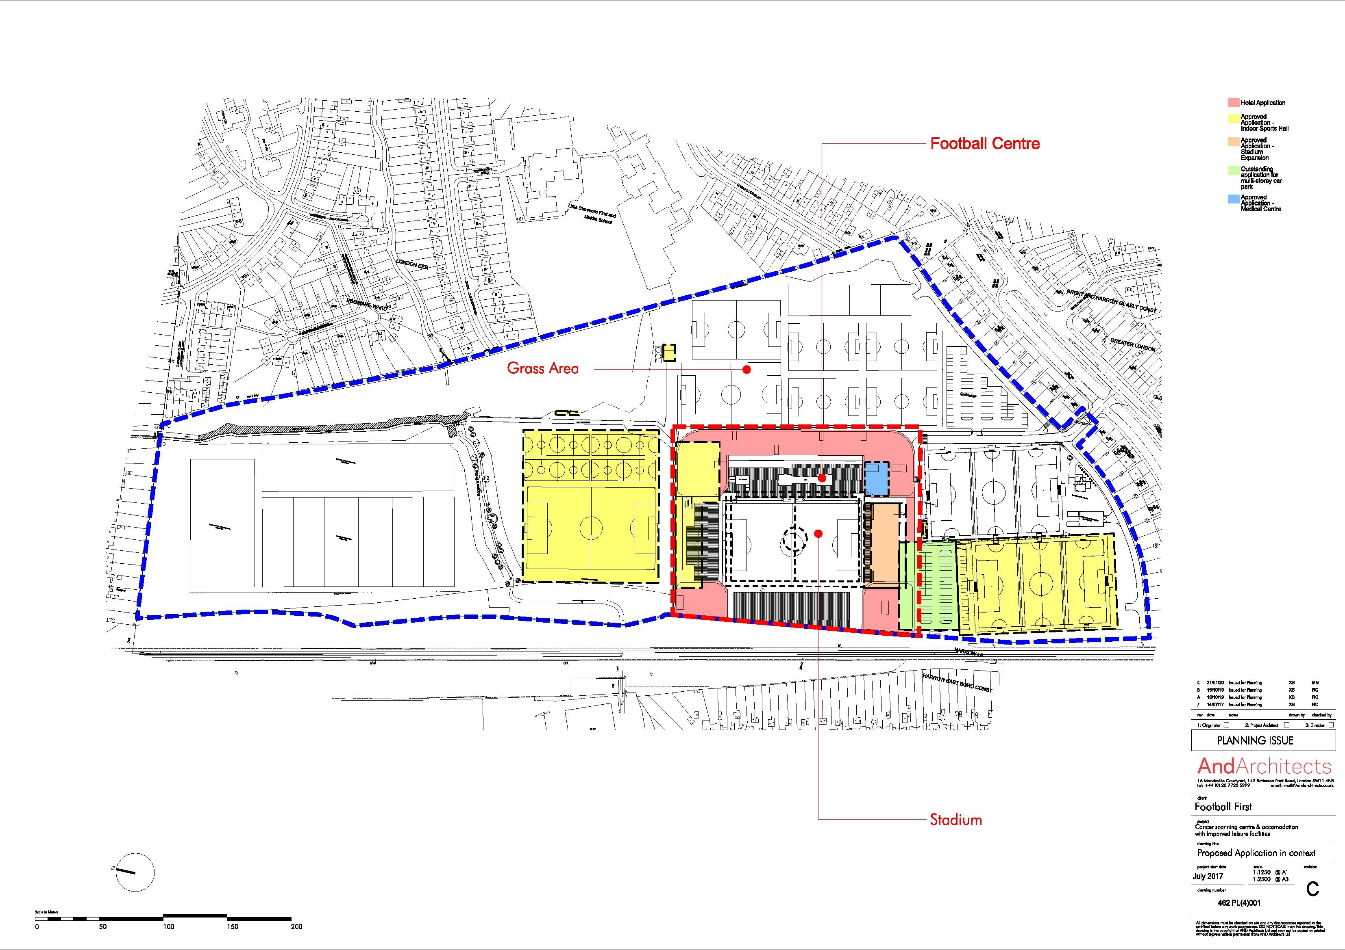

APPENDIX 3: PLANS AND ELEVATIONS
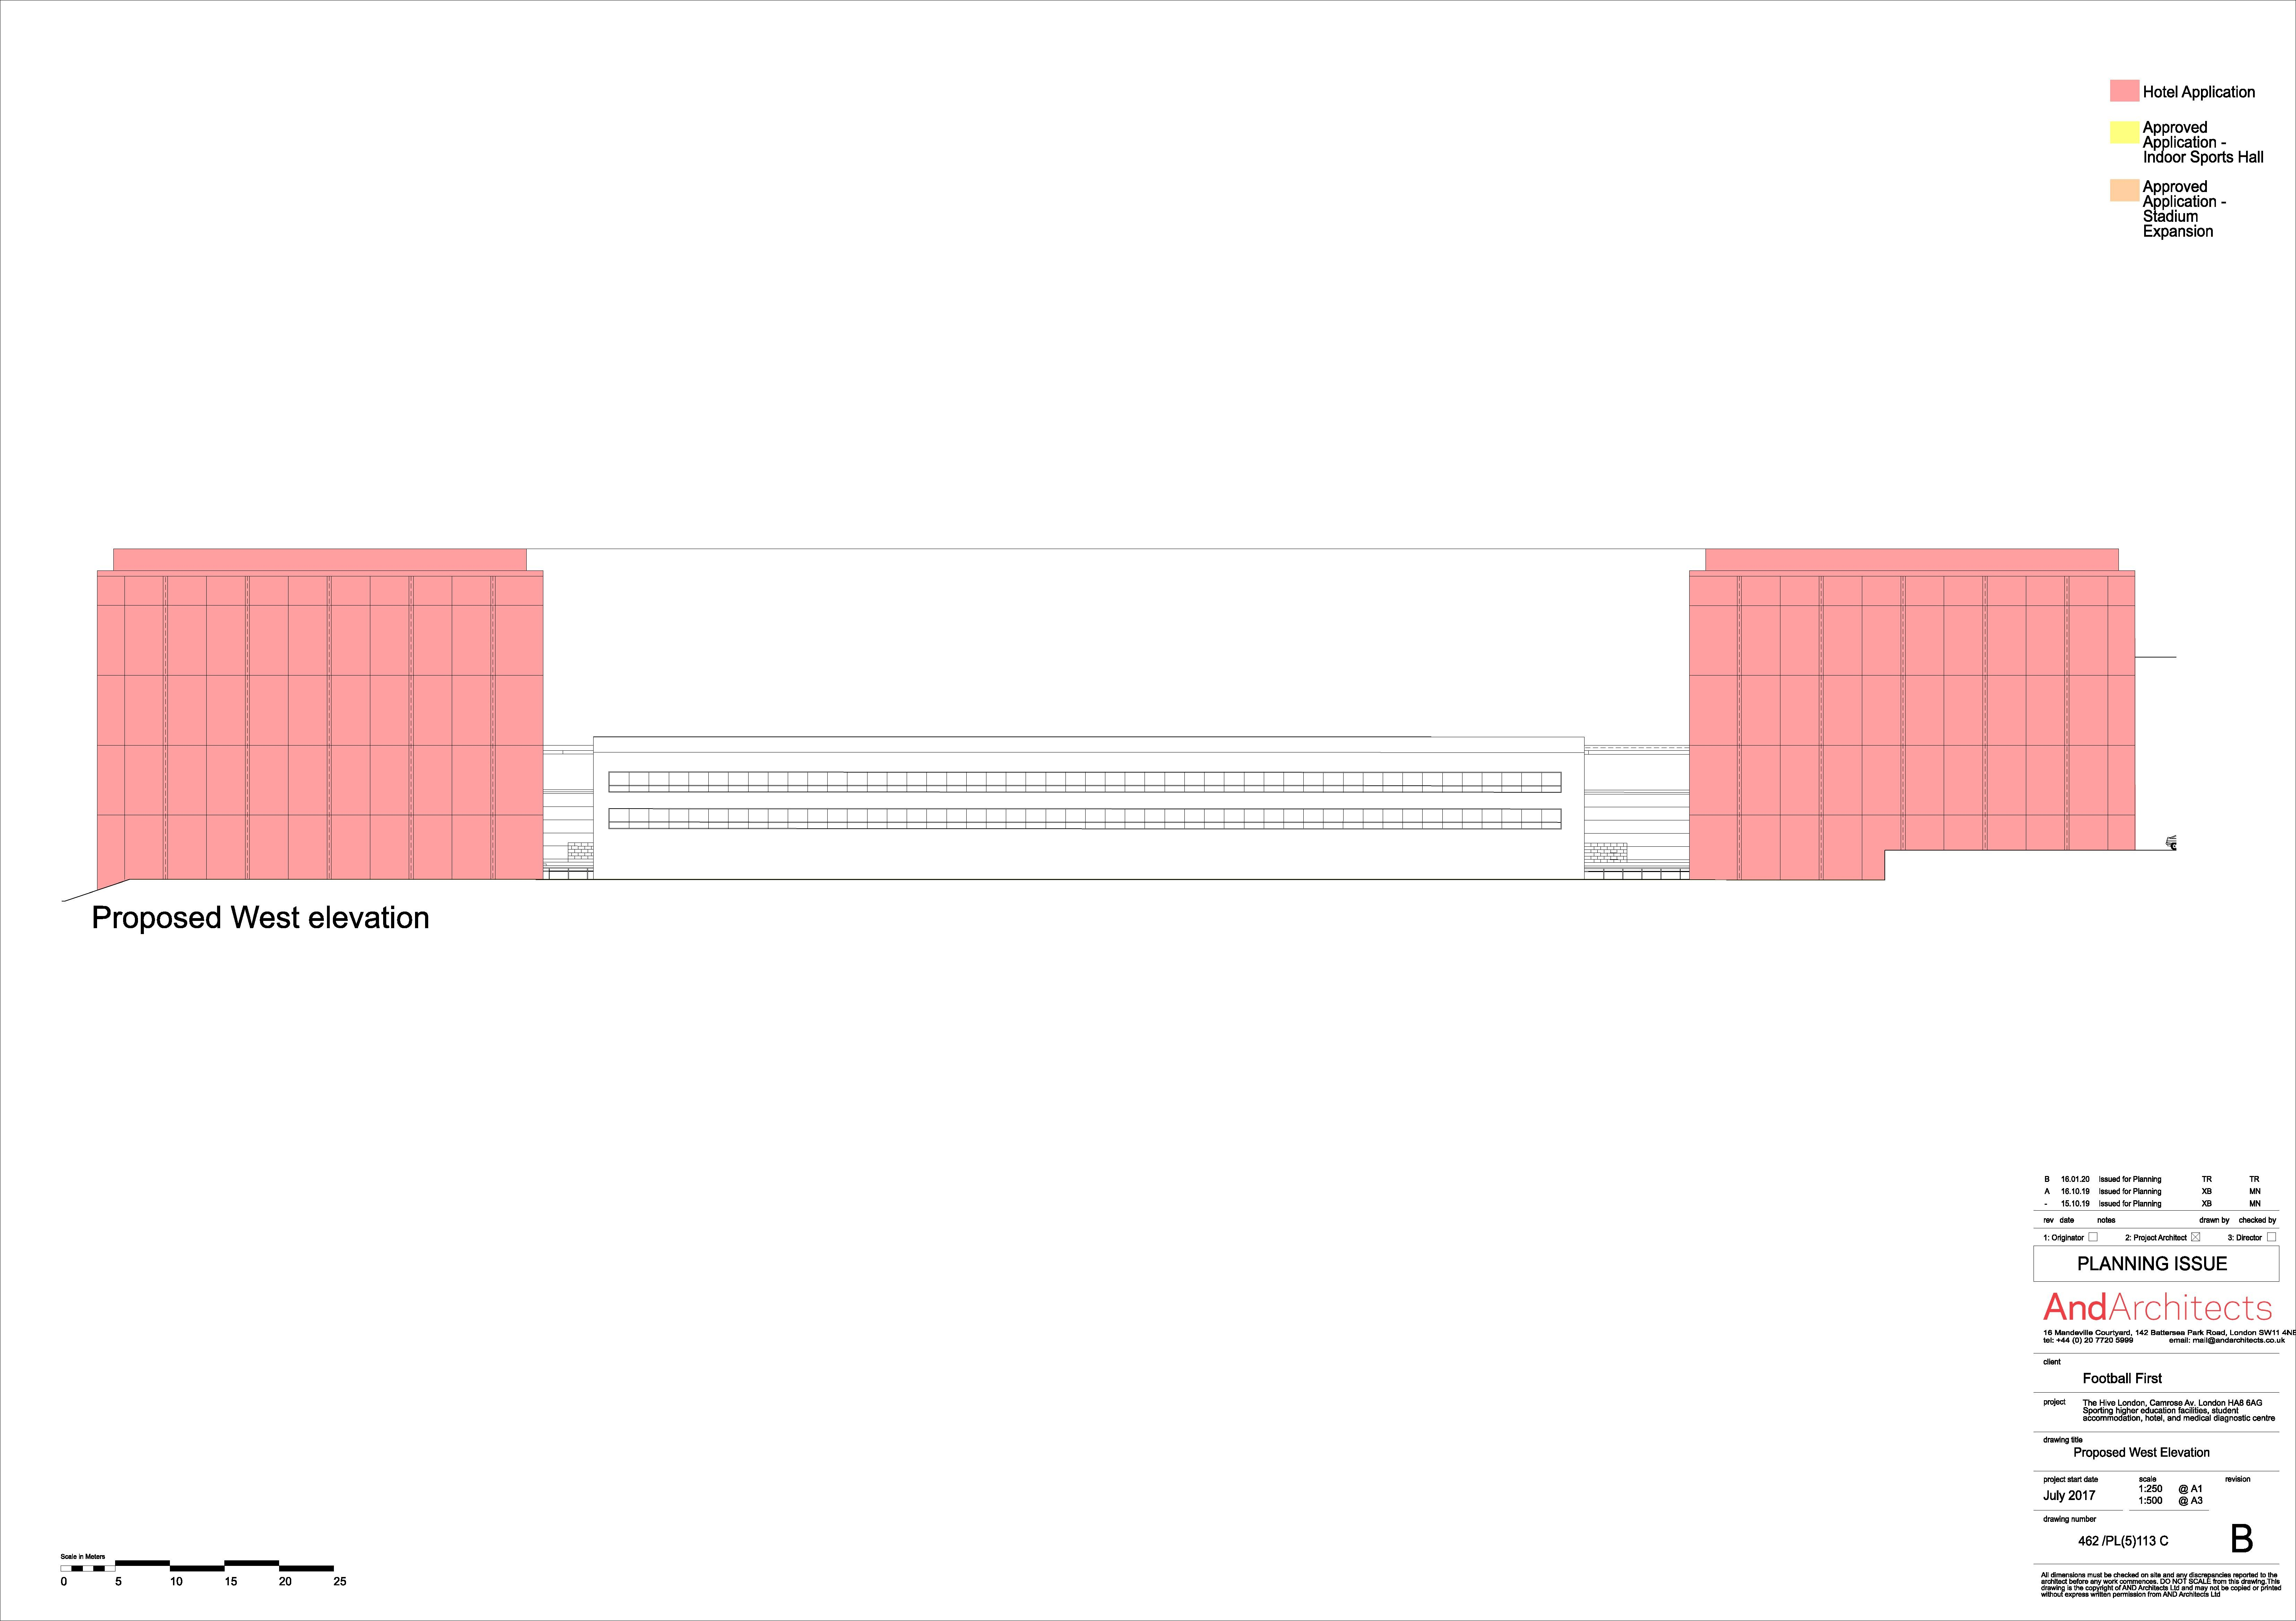
Indicative West Elevation

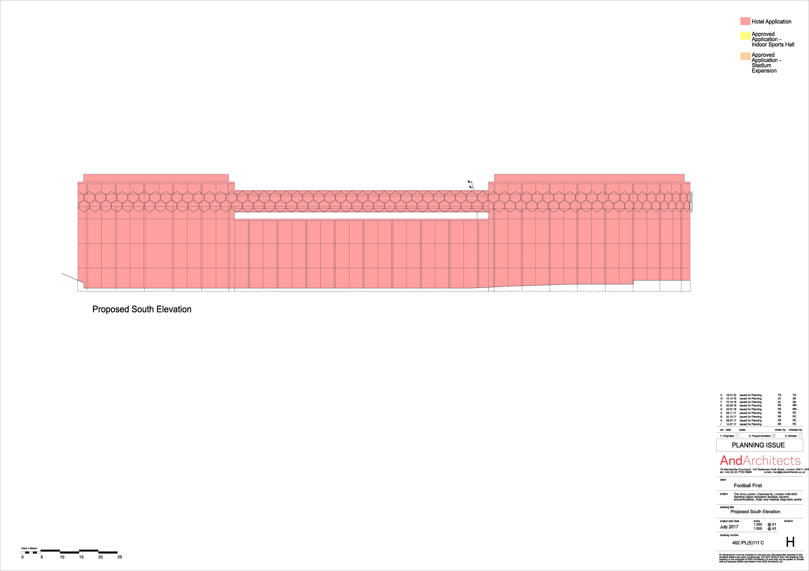
Indicative South Elevation
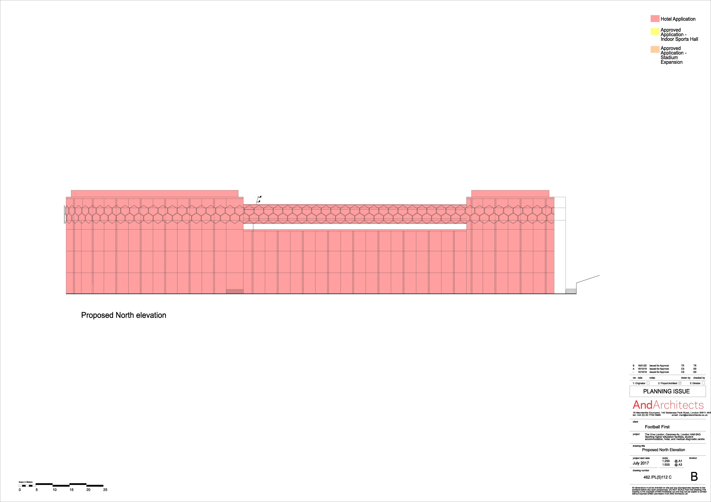
Indicative North Elevation
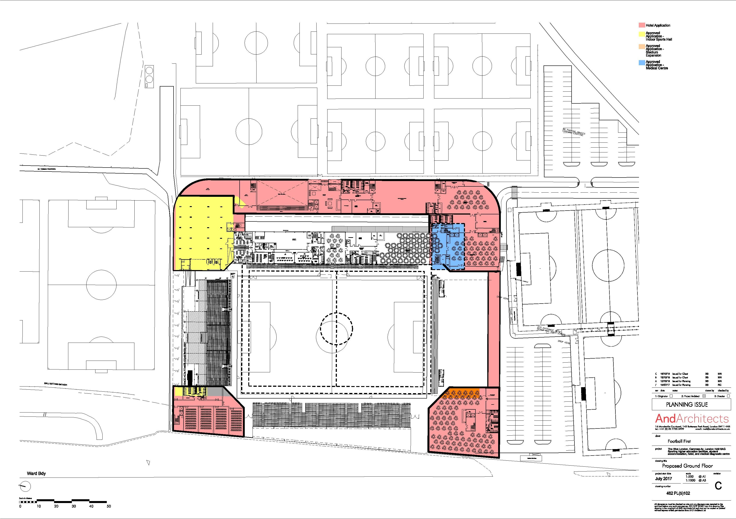
Indicative Ground Floor Plan

Indicative Images:

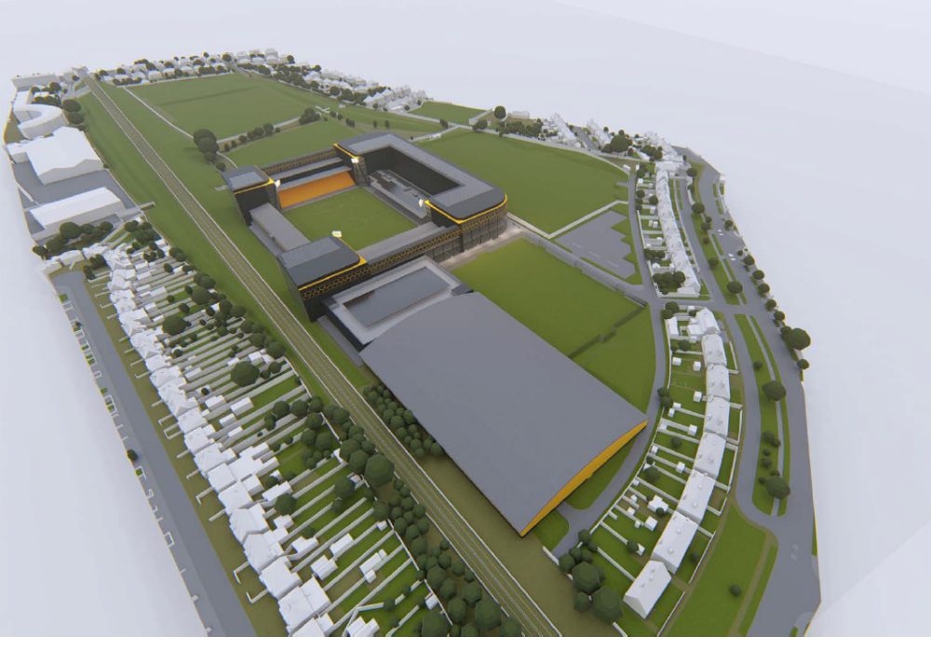

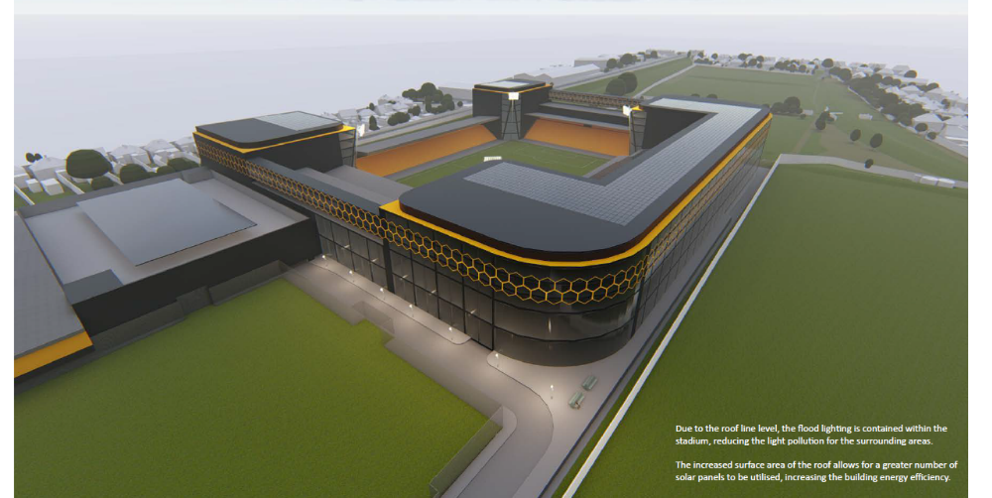

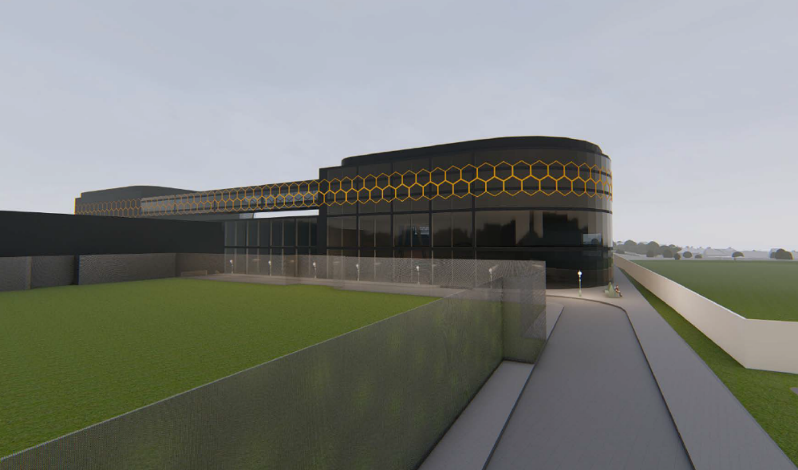

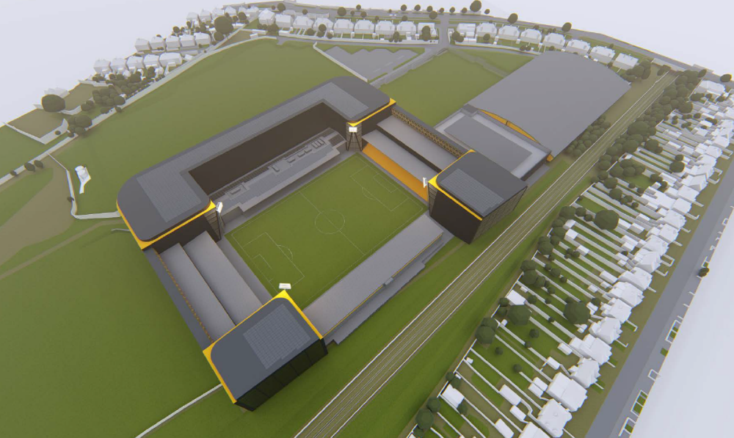

APPENDIX 3: SITE PHOTOS



